Knowledge, Attitude, and Practice of First Aid Among Bambari Football Players

Irakoze jean claude

# Abstract

Injuries are common among footballers, with studies showing that per 1000 hours of play, the probability of being injured is between 10% and 35%. Evidence indicates that a lack of first aid (FA) care negatively affects health outcomes. This study aims to evaluate the knowledge, attitude, and practice of FA among Bambari football players. In this cross-sectional study conducted on football players in Bambari city, Central African Republic (CAR), a questionnaire assessed sociodemographic properties, FA knowledge, attitude, and practice. This study was approved by the CAR football federation. Among the 126 participants, the mean age was 26 years, with 83 (66%) having a secondary school education level. Results showed mean knowledge in FA at 19.76%, a positive attitude at 83.06%, and inappropriate practice at 17.05% among the 21.62% who reported involvement in FA practice. We conclude that Bambari football players have weak knowledge, a positive attitude, and inadequate practice of FA. We recommend that FA training be integrated into other training programs received by football players.

# Keywords

First aid, Football, Training programs, Central African Republic football federation, Knowledge.

# Introduction

FA is the immediate assistance given to any person with a minor or serious illness or injury, aiming to preserve life, prevent further harm, and promote recovery.[1-9] Historically, the term "FA" was first used in 1870 by surgeon Johannes Friedrich von Esmarch, who taught soldiers the standards for treating battlefield injuries.[10] FA can be initiated by anyone in any situation [7], proving that everyone should have knowledge of FA. Studies have shown that only 15.2% of people have good knowledge of FA.[11] Promoting knowledge in FA training facilitates the provision of emergency services and can save many lives.[12,13]

Studies show that football players are at high risk of trauma. Given its global popularity, it is important to provide FA training programs to football players so they can render basic FA in emergencies.[14] In CAR, the Central African football federation, founded in 1961 and affiliated with FIFA, is the governing body of football.[15] Adequate knowledge, a positive attitude toward FA, and good FA practice among football team members may reduce morbidity and mortality among players and the general population due to injury and acute illness.

# Literature Review

Injuries are common among footballers, with studies showing that per 1000 hours of play, the probability of being injured is between 10% and 35%.[1] Due to an increasing number of deaths from sudden cardiac arrest among players, International federation of association football (FIFA) recommends regular cardiopulmonary resuscitation (CPR) training for players, coaches, and staff members. Studies have shown that every year between 2014 and 2018, hundreds of football players were victims of sudden death during a match or up to an hour and a half later, resulting in a 76% mortality rate.[2] In 2021, after footballer Eriksen's death on the field due to cardiac arrest, the Italian football federation announced a FA project to enable players to react immediately and effectively in such events.[3] Studies indicate that the probability of death within the first five minutes after an accident is 35%, and within the first thirty minutes, it is 54%.[4] Evidence shows that a lack of FA care negatively affects health outcomes, while the availability of FA care results in a 25% reduction in trauma-related mortality.[5] Ensuring that victims receive life-sustaining care within a few minutes of injury can accomplish considerable good.[6] Beyond health matters, FA knowledge also increases social responsibility and strengthens societal values.[7] understanding basic FA can help save lives before emergency medical services arrive. Studies show that FA knowledge can be disseminated in various settings, such as households, schools, workplaces, recreational areas, self-reading, media, and international rescue since 2000, the International federation of red cross and red crescent societies and its national societies have honored FA on the second Saturday of September each year to raise public awareness of how FA can save lives every day.[8]

No previous studies have assessed the knowledge, attitude, and practices of FA among football club members in Bambari City, Central African Republic. This study aims to assess the gap between footballers who have knowledge of First aid and those who do not, using dependent variables such as FA knowledge, attitude, and practices.

# Methodology

**Study area**: Bambari is a town in the CAR, located on the Ouaka River. It has a population of 41,356. Ethnic violence has plagued the CAR for decades, but community engagement has helped to reduce tensions by bringing former antagonists together in less lethal meetings. One recent example is football in Bambari.[14] This study aims to evaluate the knowledge, attitude, and practice skills of FA care among members of Bambari football teams.

**Study population:** A cross-sectional study was conducted among the members of football teams in Bambari. There are 12 football teams, each with 30 members. Football clubs are important in society and can help in health promotion. They also reflect the active population, which requires concentrated efforts in all domains, including health.

**Study duration:** The study will be carried out from 1st to 30th November 2023.

**Sampling method:** We will use a cluster sampling method. Data will be collected using a modified questionnaire from a previous study, which includes demographic information, a FA knowledge questionnaire, a FA attitude questionnaire, and a practice skill checklist.

Sample size: Sample size is calculated using sample size determination formular for single population proportion. The following formula is used to estimate the minimum number of footballs required for the study.[31]

n =(Z/a)2 x P x Q/d2

Z/a is confident interval of 95% which is 1.96

P is expected proportion which is 15%

Q is standard deviation

d is standard of error 5%

If 15% of the subjects in the population have the factor of interest, and a population size of 360, the study would require a sample size of 127 for estimating the expected proportion with 5% absolute precision and 95% confidence.

**Study tools and various schedules:** A self-administered questionnaire comprised three parts:

* + Part, one includes six demographic questions such as age, sex, education level, and profession.
  + Parts two and three consist of 10 close-ended questions for assessing FA knowledge and 6 questions for assessing FA attitude. These assess FA training evaluation, bleeding treatment knowledge, cardiopulmonary resuscitation, trauma management, chest pain management, and FA attitude.
  + The last part consists of 12 open-ended questions on airway management practice, bleeding management, bone fracture management, and cardiopulmonary arrest management.

**Pretesting:** The content validity was established by a panel of 5 experts (five football players who were not included in the study), who reviewed the tools for clarity, relevance, comprehensiveness, understanding, applicability, and simplicity for implementation. Based on their feedback, some modifications were applied. The appearance of measurement and content-related validity considered all major elements relevant to the construct being measured.

**Collection of data:** Meetings were held with the 12 team leaders to explain how the questionnaire was structured and how to complete it. The questionnaires were written in English, which is the language used in CAR. Team leaders helped administer the questionnaire to participants and guided football players if there were any concerns during self-report data collection.

**Data analysis:** The collected data was coded, cleaned, entered, and analyzed using Microsoft Office forms.

**Ethical consideration:** The study was reviewed and approved by the CAR football federation. Participation in the study is voluntary, and the names of participants are not mentioned in the questionnaire.

# Results

**Socio-demographic factors:** The respondent was all male and are all from Bambari city in CAR.



**Level of education**

**20%**

**14%**

**66%**

Secondary University

3rd Qtr

Figure 1: Level of education

|  |  |  |
| --- | --- | --- |
| **Age in years** | **Frequency** | **Total mean** |
| 15-19 | 19 | 289 |
| 20-24 | 31 | 682 |
| 25-29 | 37 | 999 |
| 30-34 | 24 | 768 |
| 35-39 | 15 | 555 |
| Mean age of participants 26 years | | |

Table 1: Age repartition

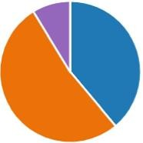**Marital status:**

 Married - 49

 Single - 66

 Separated - 11

Figure 2: Marital status

**FA knowledge evaluation:**

FA training evaluation



**15%**

**85%**

No FA training

FA trained

Figure 3: FA training evaluation



Have you ever heard of First Aid?

**28%**

**72%**

Yes

2nd Qtr

Figure 4: Source of FA information

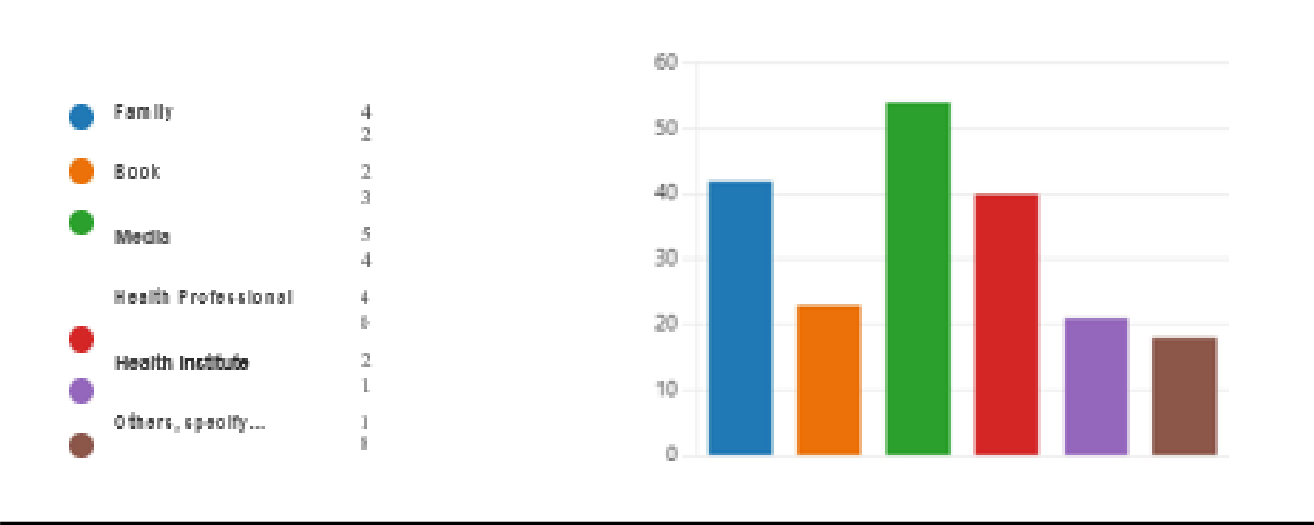

Figure 5: Assessing priority in FA

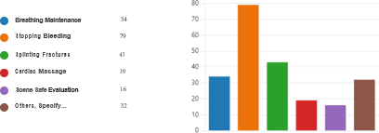

Figure 6: Assessing priority in FA



**Bleeding management knowledge evaluation**

**1G%**

**38%**

**32%**

**11%**

direct pressure Remote pressure Apply Tourniquet

Don't Know what to do

Figure 7: Bleeding management knowledge evaluation



**Suffocating management evaluation**

**22%**

**25%**

**40%**

**13%**

Leaving in same position Giving slaps on the back Abdominal compression

Don't know what to do

Figure 8: Suffocating management evaluation

Figure 9: FA Worker protection assessment



**FA worker protection assessment**

**18% 2G%**

**13%**

**40%**

Emergency Extraction

Use of PPE

Observation from Distance

Don't Know

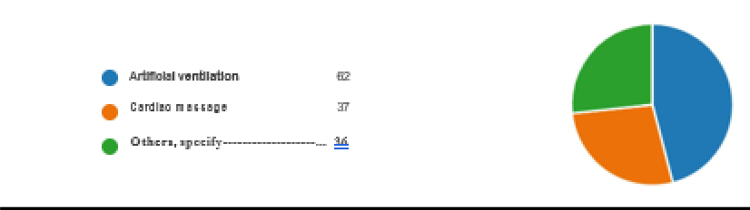

Figure 10: Trauma management evaluation

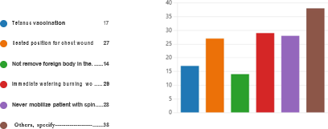

Figure 11: Chest pain management evaluation



Figure 12: Chest pain management evaluation

Mean FA knowledge of participants was 19.76 %.

|  |  |  |  |  |
| --- | --- | --- | --- | --- |
| **Serial** | **Questions assessed** | **n responses** | | **Percentage %** |
| Yes | No |
| Which of the following techniques are used to stop bleeding? You can select more than one | Direct pressure | 62 |  | 49.20 |
| Remote pressure | 18 |  | 14.28 |
| Apply tourniquet | 51 |  | 40.47 |
| Don’t know | 31 |  | 24.60 |
| Which of following measures used for suffocating victims | Living in same position | 40 |  | 31.74 |
| Giving slaps on the back | 28 |  | 22.22 |
| Abd compression | 62 |  | 49.20 |
| Don’t know | 34 |  | 26.98 |
|  | Emergency extraction | 40 |  | 31.74 |
| Which of following can be done by FA workers for protection | Usage ofPPE | 57 |  | 45.23 |
| Observe from distance | 18 |  | 14.28 |
| Don’t Know | 26 |  | 20.63 |
| Which of the  Can the following be done in FA for CPR? | Artificial ventilation | 62 |  | 49.20 |
| Cardiac massage | 37 |  | 29.36 |
| Don’t know | 36 |  | 28.57 |
| Which of the following can be done first  aid worker for victims who have trauma? | Tetanus vaccination | 17 |  | 13.49 |
| Seated position for chest trauma | 27 |  | 21.42 |
| Not removing foreign body | 14 |  | 11.11 |
| Immediate watering burning wound | 28 |  | 22.22 |
| Never mobilize victims with spine borne trauma | 23 |  | 18.25 |
| Don’t know | 36 |  | 28.57 |
| Which of the following can be done for victim complaining chest pain? | Regularly check conscience | 27 |  | 21.42 |
|  | Gard in rest position | 54 |  | 42.85 |
|  | Ask information for PMH | 25 |  | 19.84 |
|  | Call for help | 35 |  | 27.77 |
|  | Don’t know | 38 |  | 30.15 |

Table 1: FA knowledge evaluation

Attitude evaluation:

Attitude evaluation

140

120

100

80

60

40

20

0

Do you believe Would you like Giving special

that is necessary to give FA immediately after incident

to provide FA care for injured

is appropriate

Do you have interest in training of FA

Do you thing

Is it the

Players should responsibility for be trained in FA every one giving

FA to victims

Yes No Don't know

Figure 13: Attitude evaluation

Respondents have a good attitude at 83.06% with high value of 91.26% in willing training for football players and low limit of 73.80% of knowing that is the responsibility of everyone to provide FA to victims immediately.

**Practice evaluation:**

Question assessing if participant have involved in giving FA care to victims at scene: Of the 29 responses received, only 9(31%) were appropriate.

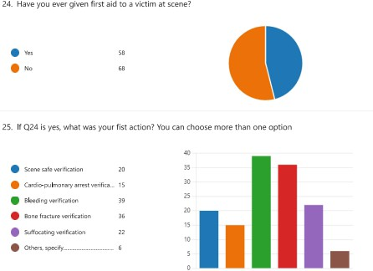

Figure14: FA care to victims at scene

Did you have a trend victim with air way problem?

Airways practice evaluation

Yes No

Figure 15: Airways practice evaluation

Did you have a trend victim with bleeds heavily?

Bleeding management Practice evaluation

Yes No

Figure 16: Bleeding management practice evaluation

Total 44(35%) responses agreed to participate in bleeding management, the response was following:

Bleeding management practice

25

20

15

10

5

0

Bleeding Management

Direct pressure

Using Tourniquet

Inapropriate response

Figure 17: Bleeding management practice

Did you have a trend victim with spine injury?: 5 (4 %) yes responses received, only 2 responses were appropriate

Spine injury management evaluation

Yes No

Figure 18: Spine injury management evaluation

Did you have a trend victim with bone fracture?

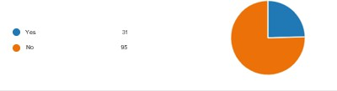

Figure 19: Bone fracture victims

All responses were correct (immobilization). All participants have not yet participate in cardiac arrest management.

# Discussion

In this study, we aimed to determine the level of knowledge, attitude, and practice of FA among Bambari football players. A total of 126 participants were randomly selected. There were no female participants in the study because, during the period we conducted the study, only the male champions league was ongoing, and it was not possible to reach females at home.

The participants had a mean age of 26 years, which is like the study conducted by Hassan M. et al. [1], where the mean age was 26.52±10.31 years.

107 (85%) participants reported that they had never attended any FA training program. However, 91 (72%) reported receiving informal knowledge in FA, mostly from media and family.

In our study, FA knowledge was assessed by evaluating the management of different emergencies, and the results showed that the mean knowledge was 19.76%. This level of knowledge is very low compared to a similar study conducted among teachers, which reported FA knowledge at 40%.[7] The low level in our study could be attributed to most participants having only a secondary level of education. However, our study's FA knowledge result is like the result reported by Sze Nok Ng et al., which was 15.2%.[31]

Participants in our study demonstrated a good attitude towards FA, with a score of 83.06%. This indicates that football players are willing to receive FA training, which will enhance their well-being and safety. A good attitude towards FA training, at 97%, was also reported in the study conducted by Hassan M. et al., which showed that football players believed FA training programs were important.[1]

In our study, only 21.62% of participants reported facing an emergency, and appropriate action was taken in only 17.05% of cases on average. This low rate of appropriate response is likely since 85% of the participants did not receive formal training.

# Conclusion

In conclusion, Bambari football players have weak knowledge, a positive attitude, and inadequate practice of FA. We recommend that FA training be integrated into other training programs received by football players to improve their knowledge and practice skills.

# References

1. Alshaqaq HM, Alfayad I, Al-Tannir M. The impact of a first aid training program on football players' knowledge: a randomized parallel controlled interventional study. *Saudi Trauma Conference*; 2019. [(PDF) The Impact of a First Aid Training Program on Football Players’ Knowledge](https://www.researchgate.net/publication/373802003_The_Impact_of_a_First_Aid_Training_Program_on_Football_Players'_Knowledge)
2. Egger F, Scharhag J, Kästner A, Dvořák J, Bohm P, Meyer T. FIFA Sudden Death Registry (FIFA-SDR): a prospective, observational study of sudden death in worldwide football from 2014 to 2018. *Br J Sports Med*. 2022;56(2):80-87. doi:10.1136/bjsports-2020-102368
3. Metin I, Mutlu C. Level of knowledge about first aid of the university students. *Trakia J Sci*. 2010;8(Suppl 2):262-265. <http://www.uni-sz.bg/tsj/vol8,Suppl.2,2010/I.Metin.pdf>
4. Mehmood A, Rowther AA, Kobusingye O, Hyder AA. Assessment of pre-hospital emergency medical services in low-income settings using a health systems approach. *Int J Emerg Med*. 2018;11(1):53. doi:10.1186/s12245-018-0207-6
5. Sasser SM, Varghese M, Joshipura M, Kellermann A. Preventing death and disability through the timely provision of prehospital trauma care. *Bull World Health Organ*. 2006;84(7):507. doi:10.2471/blt.06.033605
6. Ganfure G, Ameya G, Tamirat A, Lencha B, Bikila D. First aid knowledge, attitude, practice, and associated factors among kindergarten teachers of Lideta sub-city Addis Ababa, Ethiopia. *PLoS One*. 2018;13(3):e0194263 doi:10.1371/journal.pone.0194263
7. HSI. World First Aid Day: Why First Aid Skills Are Important.

<https://hsi.com/blog/world-first-aid-day-why-first-aid-skills-are-important#:~:text=The%20importance%20of%20first%20aid%20skills%20training,taken%20to%20control%20severe%20bleeding>.

1. Adam Felman. First aid recovery position and CPR. Medical News Today. 2018. <https://www.medicalnewstoday.com/articles/153849>
2. Pearn J. The earliest days of first aid. *BMJ*. 1994;309(6970):1718-1720. doi:10.1136/bmj.309.6970.1718
3. Shakeri K, Fallahi-Khoshknab M, Khankeh H, Hosseini M, Heidari M. Knowledge, attitude, and clinical skill of emergency medical technicians from Tehran emergency center in trauma exposure. *Int J Crit Illn Inj Sci*. 2018;8(4):188-193. doi:10.4103/IJCIIS.IJCIIS_33_18
4. Heard CL, Pearce JM, Rogers MB. Mapping the public first-aid training landscape: a scoping review. *Disasters*. 2020;44(1):205-228. doi:10.1111/disa.12406
5. Nelson BD. *Essential Clinical Global Health*. Wiley-Blackwell; 2014:528 pages.

<https://www.wiley.com/enin/Essential+Clinical+Global+Health%2C+Includes+Wiley+E-Text-p-9781118638446>

1. Alshaqaq H, Alfayyad I, Altannir Y, Al-tannir M. Comparing two methods of education on first aid knowledge among Saudi football players: an experimental study design. *Eur J Sport Sci*. 2019;7(2):10-20. <https://www.scholarsresearchlibrary.com/articles/comparing-two-methods-of-education-on-first-aid-knowledge-among-saudifootball-players-an-experimental-study-design-18438.html>
2. Central African Football Federation. [https://en.wikipedia.org/wiki/Central_African_Football_Federation](https://en.wikipedia.org/wiki/Central_African_Football_Federation%20)
3. Dvorak J, Kramer EB, Schmied CM, et al. The FIFA medical emergency bag and FIFA 11 steps to prevent sudden cardiac death: setting a global standard and promoting consistent football field emergency care. *Br J Sports Med*. 2013;47(18):1199-1202. doi:10.1136/bjsports-2013-092767
4. Hanson JR, Carlin B. Sports prehospital-immediate care and spinal injury: not a car crash in sight. *Br J Sports Med*. 2012;46(16):1097-1101. doi:10.1136/bjsports-2012-091800
5. ATAC Team. First aid basics: step-by-step guide for common emergencies. 2024. <https://www.uscpronline.com/first-aid/basics>
6. U.S. Department of Labor, Occupational Safety and Health Administration. Best practices guide: fundamentals of a workplace first-aid program. 2006. [Medical and First Aid - Overview | OSHA.gov | Occupational Safety and Health Administration](https://www.osha.gov/medical-first-aid)
7. Infirmiers.com. Course - Cardiopulmonary arrest (CPA). 2023. <https://www.infirmiers.com/etudiants/cours-et-tests/cours-l-arret-cardio-respiratoire-acr>
8. Schatzki SC. First aid. *AJR Am J Roentgenol*. 2014;202(6):1395. doi:10.2214/AJR.13.12257
9. Blake K. What you need to know about hemorrhage. *Healthline*. 2019. <https://www.healthline.com/health/bleeding>.
10. International Federation of Red Cross and Red Crescent Societies. International first aid, resuscitation, and education guidelines. 2020. <https://www.ifrc.org/document/international-first-aid-resuscitation-and-education-guidelines>
11. Dersakissian, C. Understanding bone fractures, the basics. *WebMD*. <https://www.webmd.com/a-to-z-guides/understanding-fractures-basic-information>
12. Harrigan, Maribeth.Fracture Management: Basic Principles, Immobilization, and Splinting. In book: Interventional Critical Care; 2021:401-411). doi:10.1007/978-3-030-64661-5_38.
13. Schuind F, Moulart F, Liegeois JM, Dejaie L, Strens C, Burny F. La contention orthopédique [Orthopedic immobilization]. *Acta Orthop Belg*. 2002;68(5):439-461. <https://pubmed.ncbi.nlm.nih.gov/12584974/>
14. World Health Organization. Basic Emergency Care: Approach to the Acutely Ill and Injured. 2018. <https://www.who.int/publications/i/item/9789241513081>
15. Johnson K, Ghassemzadeh S. Chest Pain. In: *StatPearls*. Treasure Island (FL): StatPearls Publishing; [Chest Pain - PubMed](https://pubmed.ncbi.nlm.nih.gov/29262011/)
16. Finnish Red Cross. Chest pain. <https://www.redcross.fi/first-aid/first-aid-instructions/chest-pain/>
17. Ng SN, Tang LK, Leung CK, et al. Knowledge and training preference of standard first aid among undergraduates in Hong Kong: a cross-sectional survey. *Hong Kong Journal of Emergency Medicine.* 2023;30(3):172-178. doi:10.1177/10249079211050148

# Acknowledgements

Not reported

# Funding

# None

# Author Information

Irakoze jean claude

Email:[iranacl1@gmail.com](mailto:iranacl1@gmail.com)

# Ethical Approval

The study was reviewed and approved by the CAR football federation. Participation in the study is voluntary, and the names of participants are not mentioned in the questionnaire

# Conflict of Interest Statement

Not reported

# Guarantor

None

# DOI

# Cite this article